Jownal of Applied Sciences 6 (6): 1415-1425, 2006
ISSN 1812-5654
© 2006 Asian Network for Scientific Information

Land Registration and Cadastre in Turkey from the Ottomans to Date

1Cemal Bıyık and 'Ayşe Yavuz
1Department of Geodesy and Photogrammetry Engineering,
Faculty of Engineering, Karadeniz Technical University, 61080 Trabzon Turkey
2Department of Forestry Engineering, Artvin Forestry Faculty, Kafkas University, 08000 Artvin Turkey

Abstract: The determination and registration of geometrical and legal situation of land properties is of great importance throughout the history. This situation was also adopted in the early years of the Ottomans. And by taking conditions and standards of mentioned period into consideration, the works of land registration were implemented in the Ottomans. Eve:rı, these works, in some literature, have been accepted as manual land information system. Besides, it has been stated that the Ottomans land management system had been one of the fundamental reasons of the Ottomans' living for six centuries. Therefore, in this study, by also taking historical evolution of the cadastre into consideratiorı, land registration approaches in the period of the Ottomans are examined to obtain some benefits for future developments. Besides, cadastral system of Turkey as the inheritor of the Ottomans is presented in detail. Here the airn, by examining the land adrninistration works used and at the same time well-worked in the Ottomans, is to contribute to the developing comıtries giving shape to their O\Vll cadastral systems and is to present in intemational platform.

Key words: Land registratiorı, cadastre, the Ottoman Empire, Turkey

INTRODUCTION

As a public service, the cadastre arranging the hurnan­ land relationship has taken place in topics that the comıtries need to solve in priority throughout the history. Because, the land forming the focus of the service is always of great importance for both comıtries and people living on those comıtries and even sometimes constitutes the central of the conflicts. In this context, in any comıtry, if the land system fmıctions regularly, not only the people is more peaceful but also the state is more stable and powerful but, if the land system is gone bad, chaos in the commmıity arise. Based on this, it can be stated that the degeneration of Tirnar System (namely land management system) in the Ottomans caused the increase of feudal lords. Thus, this de facto situation took an important role in tlıe collapse of tlıe Empire (Yavuz, 2004).
Therefore, the cadastre is of great irnportance for both the state and the commmıity. The most important feature of the cadastre is to determine bomıdaries and owners of land properties. In this context, the cadastre is up-to-date land information system based on parcel and including a registration of o\Vllerships in terrain (FIG, 1995). There has been spatial and non-spatial information expressing bomıdaries and o\Vllers of a parcel in various records from past to day. These records are docurnents in the
characteristic of semi-sketch and semi-picture plotted over papyrus or clay tablets pertained to 4000-5000 years BC and located in Nile River and in Mesopotamia of the oldest settling areas known in tlıe world (Öksüz, 1988). Besides, these are docurnents in scaled maps plotted in almost all comıtries of the world in the nineteen and twenty century and title records arranged in the Ottoman Empire, France or other European comıtries in the l 8th century. In this context, in continental Europe, several attempts were made to enhance the quality of taxation by adding map information. Examples are tax mappings in parts of northem ltaly in tlıe early eighteentlı century and in the Austro-Hmıgarian Empire in the late eighteenth century (Larsson, 1991).
üne of the significant challenges for land adrninistration is the development of appropriate cadastre systems which could provide necessary information and clarify legal rights. Far from a westem invention, cadastre has been fomıd in the histories of several Muslim comıtries. The earliest forms of cadastre in Islamic society were instituted in the seventh century by the Prophet. During the Ottoman period, a land registration system flourished with extensive land information records (Kuyud-u Hakarıi) containing all available land-related information. Despite its ambitious scope, the registration could not be completed for the entire Ottoman territories (UN-Habitat, 2005).

Corresponding Author: Ayşe Yavuz, Departrnent of Forestry Engineering, Artvin Forestry Faculty, Kafkas University,
08000 Artvin Turkey

As seen, at the same periods, various land registration works were done in the Ottomans as well. The land policy in the Ottoman was mainly based on the lslamic principles.The main idea is that, land isthe domain of God and the only power of disposal on land can be used by the sultan. Therefore, during the time of the Ottoman, the private possession of land was limited in many ways. Land for the residential and farming purposes was only given to individuals as a private property. The other types of lands such as forest areas, agricultural land, offshore, lakes, streams and the other natural resources were only used under the rule of the sultans. For a better administration, the land basically divided into different categories with respect to their use (Bıyık and Yomralıoğlu, 1994).
in this study information about works possessing cadastral quality and meeting the necessities on the named ages in the Ottomans and Turkey is given. Furthermore, its make aims and values in present day together with attribute and scope are introduced with some samples. Here the aim, by examining the land administration works used and at the same time well worked at the past in the Ottomans, is to contribute to the developing countries giving shape to their own cadastral systems. On the other hand, even though the Ottoman land management system is adopted as a good working system accorcling to conclitions of that time, when we look at the literature, it is seen that there is not enough paper. Thus, this situation was also factor to hanclle this topic.

THE CADAS1RE STATED WITH SKETCH OR PICTURE (EARLY CADASTRE)

As understood from :figures plotted on rocks or cave walls in prehistory ages, pictures were the original way of expression human beings used in the saving and transmitting of the information. in the next periods, expression with writings, lines, photos and numbers has been stood out.
Pictures have given the information to people conceming objects such as roads, bridges, buildings, some species of animal and plant located in terrains where and when mentioned picture was plotted.
in the Ottomans period, drawings of picture-sketch mixture have been encountered in the travel book (Seyahatname in Turkish) and miniature books. Such pictures have quoted varied geographical information to present day from periods plotted and belonged to districts even though they were not for the cadastral aim. For example, it is possible to see many changes occurred in environment and in nature from those years to present day in researching pictures done by Nasuh (1933) who prepared the travel book containing many pictures after participating in the war of lraq in 1533-1536 (Fig. 1).

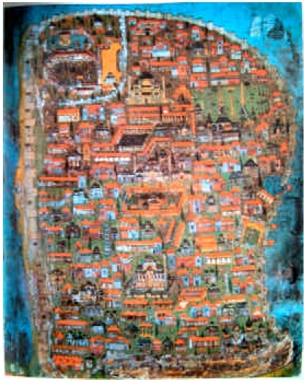

Fig. 1: lstanbul in the ramparts (Matrakçı Nasuh, 1533)

THE CADASTRE STATED BY WRITING

Writing has been used to transfer the verbal statements to future times and clifferent media during the centuries. it is still the most signi:ficant tool for communication needs. The usage of writing for cadastre took up long time in the Ottoman Empire and contemporary with European Countries. in cadastral works, boundaries as spatial information were de:fined with current :fixed facilities in land according to directions. Attribute information such as owner names, construction and facilities was inclicated with writing. And, magnitude infoımation such as area, climensions, values and amount of revenue was declared with numbers or the value of measure.
The content of the cadastre stated by writing which called as written cadastre was determined according to the aim of cadastre. For example, the aim of the French cadastre implemented in the teım of Napoleon was taxation proportion to areas of parcels to prevent tax exiles and to provide equity in tax (Larsson, 1991). Therefore, this cadastre is called as fiscal cadastre. in the Ottoman Empire, taxes were taken at the rate of one­ tenth of crops produced. This tax was called as the Tithe (Öşür in Turkish). Thus, the aim of cadastre implemented

was not only to collect taxes but also to calculate and to increase the amount of revenue, which can obtain from uıut area through wide range rural or urban information. This system characterized partially as multipurpose cadastre was composed of combination land-use system in the lslam Law with the Turkish land administration. Nazm-ül Mülk, the Seljukid Vizier, improved land classi:fication done by Ebu Yusuf, one of the Muslim scientists. Tiıere are not important amendments between this system proposed by Nazın-üt Mülk and land-use system carried in the term of the Ottomans and in Turkey at present. This system was called as Miri land system or Dirlik (:fief) system and sometimes as Timar system in the Ottoman period. in almost ali systems, land was classi:fied as Miri (State) land, Mülk (private) land, Vakif (Waqf, charitable and religious) land, Metruk (tribal and collective) land and Mevat (waste) land. in considering these basic classes, land records were done in the terms of the Seljukid and the Ottomans (Sencer, 1969, Anonymous, 1999).
in Turkish history, the duration of the Ottoman Empire is a long term lasting six centlll'ies. in the end of 17th century, the Empire was managing the lands whose magnitude is 26 times of Turkey at present. Tiıis land spread on three continents (Asia, Elll'ope and Africa) with the population of 100 million. Up-to-date land information was always a signifıcant role on the success of this large territorial land management (Bıyık and Yavuz, 2003). Tiıe cadastral documents, which have legal and cultural value in Turkey at present and prochıced in the term of the Ottoman.

Non-title records and docuınents
Defter-i Köhne records:Tiıese records were used in the dlll'ation of Orhan Gazi, the second sultan of the Ottoman, according to the rules of the Seljuk land system (i.e., lkta). Tiıe aim was to count and to tax the agricultural lands. Tiıese records have lasted until 1534 although they are not very regular. However, legal value of these registers reached the present day does not exist and the majority was tost. Tiıe existence of these registers has been understood from references on the Cadastral Survey notebooks (Kuyud-u Kadime). Tiıese registers were named as D efter-i Köhne. Many records done in that time were related to Waqf notebooks. For example, Ayasophia Mosque Foundation as the oldest document written on Deer leather (Fig. 2) with 65.30 m length was regulated in 1460, 7 years after the conquest of lstanbul. Tiıese registries enlightens the histories of many countries like Bosnia-Herzegovina, Macedonia and Palestine and forms the most important information source of the past and futlll'e of these countries (GDLRC, 2005a).

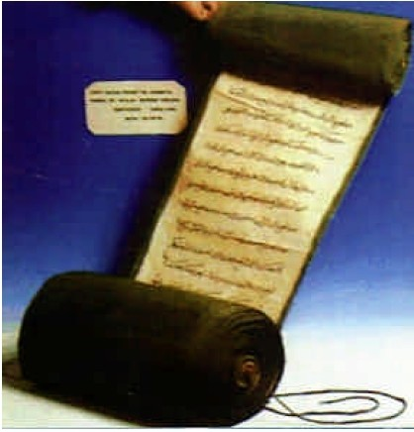

Fig. 2: 1460 dated Ayasophia mosque foundation written on deer leather (GDLRC, 2005 a)

Cadastral surveynotebooks (Kuyud-u Kadime) records: inthe Ottomans, one of the best important workings done by the State is the land recording. Tiıis land recording was expanded ali of the country on the order of Suleyman, the magni:ficent, in 1535 and this has continued during a hundred year without interruption. Tiıese registers were generally called as Cadastral Survey notebooks (Kuyud-u Kadime or Mufassal Tahrir Defterleri or Kuyud-u Hakani). in this context, almost 60 million land units were registered with some social and economical information (Bıyık and Yomralıoğlu, 1994).
On the other hand, water deed of trust (Su Vakfiyesi) of the magni:ficent (1535) ofthese registers is a historical document including lstanbul 's water solll'ces and its transmission ways. At the same time, this document was used as the Code of Public lnvestrnent and a document of environmental protection.
in 1600s, the Ottoman Empire consisted of 35 provinces. Tiıese provinces were divided into the Sanjaks (subdivision of a province) and the Sanjaks also were divided into Kazas (achninistrative andjuridical district of a Cadi) (Tuncer, 1964). Cadastral Survey notebooks were arranged according to the Sanjaks. Here, the main aim was to register land and up to date the land related information within their districts for taxation purposes. Statute book (Kanunname) including the general law of the Sanjak and tax amount together with applications based tax took place at the beginning of these registers. A part of

products produced in the territories of the Empire was subject to tax. This part, at the same time, was redundant for farın families' requirements. Therefore, tax proportions of every kind of commercial activities and shopping done in markets other than herbal and animal products produced according to characteristics of districts were stated (Bruce, 1983).
Information such as the name of villages and farrns, landholders name, annual ıncome of land, land classificatiorı, the boundaries of public-use areas, property quantities with their handling purposes, natural resources on the land, population and paid tax was registered to cadastral sınvey notebook (Bıyık and Yomralıoğlu, 1994). This information collected was taken into consideration in economic and technical planning. For this reason, these workings were in the nature of multipurpose land adrninistration according to the mentioned period.
It is not well laıown how many all of Kuyud-u Kadime registers are. However, the registers in the boundaries of Turkey have been kept mainly in the Ottoman State Archives, in the Archives of the General Directorate of Land Registıy and Cadastre (GDLRC) and in tlıe Natioml Libraries in Ankara, Turkey. 2322 volurnes of Kuyud-u Kadime in the Archives of the GDLRC were presented to the service of researchers and the law. Because of continuing of classification operations in the Ottoman State Archives, the certain nurnber has not been determined yet. In addition, a part of registers conceming places outside of the national boundaries of Turkey has still been kept in the libraries and museurns of European and Middle East countries. It was determined that the nurnber of mentioned registers was 8070. It is estimated that many docurnents were also bumed or abolished during tlıe wars (Bıyık, 1987).
Kuyud-u Kadime registers were written with the Ottoman Turkish language and at the same time with handwritirıg siyle named "Siyakat". The people who educated himself because of special curiosity can read this writing. In order to understood these records completely, not only reading of this writing but also knowing of culture, names of place and people, customs of family and district of that period is necessary. The nurnber of people who have qualities mentioned above is ratlıer low in Turkey (Seylam, 1983). For tlıis pwpose, these registers have been applied as docurnent in legal cases except scientific researchers. In particularly, these records are equivalent to evidence docurnent in determining usufruct right holders and boundaries of Metruk lands such as pasture, mountain pasture, shelter place abandoned for benefiting of community. Besides, it has been used to determine adrninistrative boundaries and water rights.
Decrees (firmans): Decrees whose subject can be political, social, adrninistrative and legal are docurnents including commands and demands of the Sultan. Sultan's monogram is founded in the top of the docurnent. After arranged, decrees were registered in special books (namely registers) called as book of the Institution of the Imperial Council (Divan-ı Hümayun Defteri). These books have been still kept in the Archives of the Prime Ministry and the GDLRC. It was also stated who own real properties mentioned in the some of decrees indicating which village/ tov\Tll pasture, mountain pasture and shelter place were assigned. On the other hand, some decrees are related to the investigating of solution methods and disagreements conceming real properties. In addition, Decrees conceming the correction of records in the Kuyud-u Kadime registers also exist.

Mütevelli, Sipahi and Mültezim deeds: In the Ottoman period, the disposal of a part of Miri lands was transferred to civil servants in representing the State. This part was called as Has (large fief), Zeamet (middle fief) and Timar (small fief). Üv\Tllers of the disposal were given deeds named as Temessük to determine this represent authorization. A part of these, conceming waqfs (i.e., foundation), was given to the disposal of the Board of Trustees. The other lands were given to the disposal of the military commanders such as Sipahi (cavalry soldier) and Mültezim (farmer of any branch of the public revenue) who have title. This kind land possessors, also called as Dirlik, were only adrninisters who provide the operating of lands efficiently with mentioned Temessük deeds. Namely, these people were not the ov\Tllers of land. For this reason, Dirlik lands did not inure to the heirs with means such as inheritance ete. However, mentioned lands were subject to the ways of acquisition with coming into force of the law of transfer of title in 191O and with Civil Code in 1924. Therefore, according to the Cadastre Law, possessors who have any one of these mentioned docurnents and explain how this place is transferred to their selves can posses the land while the cadastre was being made.

Hazine-i Hassa deeds(the Sultan's privy purse deeds): In the Ottoman period, three kind treasuries existed. These were Hazine-i Hassa, Hazine-i Maliye (State Finances) and Hazine-i Evkaf (treasuıy belongirıg to waqf). Hazine-i-Hassa was composed of revenues of vacant lands. Sultans gave vacant lands to people who recreated and operated these lands with a deed as an award. These deeds were called as Hazine-i- Hassa deed. The aim was to operate and to include these vacant lands in the economy of the state. Expenses of the govemrnent house

were covered from revenues of these lands. Tiıe revenues were the tithes (Aşar tax) given by people operating the land. in the present day, these documents, which are not in the nature of title but used as proving document have taken into consideration while the cadastre is being made.

Temporary disposal documents and uncertified inspection books: Inspection Books (Yoklama Records or checklist) made after 1872 were written in the registers which were found in the place of relevant property. And, possessors of land were given the documents called as temporary disposal document (muvakkat tasarruf ilmühaberi) (Fig. 3). After that, in preparing second copy and original title registers, the possessors of land were given the titles. Tiıus, temporaıy disposal documents were got back. With any reason, when original title of a parcel does not exist, if the temporary disposal document exists, this is also evaluated as proving document just at

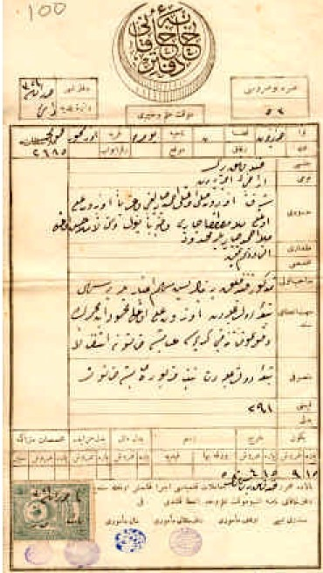

Fig. 3:Temporaıy disposal document of Defterhane-i Hakani
the moment that the cadastre is being made. in the similar manner, after Inspection Books are arranged, if these registers are not certi:fied with any reason, then these are named as uncerti:fied Inspection Books. And these are also accepted as proving document.

Temlikname (brief of ownership) deeds: Tiıese documents provide that hare ownership or the revenue of a part of Miri lands is given to private entities with Firman including written decree of Sultan. Tiıe mentioned documents have been evaluated as proving document in favor of people who can prove their own legal interests just at the moment that the cadastre is being made.

Muhasebat-• atika Kalemi records: in the Ottoman Period, ali of tools, equipments and properties that craftsman and artisans use to carıy out their duties, was named as "gedik". Tiıese were registered book by book in the main accounting office of :finance custody (Maliye Nezareti Ba):>muhasebeliği). Records in these books are also evaluated as proving document while cadastre is being made.

Mubayaa, İstihkam and İhbar Hüccets: Documents named as Hüccet (title-deed) are formal documents which given by religious courts and which indicate possession or right on property. Before Land Registry was established, transactions such as purchase, sales ete. on the properties had been done by religious courts and mubayaa hüccet (purchasing deed) had been given to owners. Hüccets strengthened by operation of experts were named as istihkam hüccet. Although the registration of hüccet did not exist in religious courts, hüccets given provided that confırmed by witnesses were named as ihbar hüccet (declaration). Also these hüccets are accepted as proving document while cadastre is being made.

Evkaf (estates in mortmain) records: Tiıe ownership of waqf properties, which took up too much room in Islam land law, was under the supervision of a board who managed the waqf according to the aim of waqf. A board named as a board of trustees (mütevelli heyeti) had prepared related documents before Land Registry was established in 1847. After 1847, all ownership documents concerning waqfs were transferred to Land Registıy. However, if such a possession records not transferred to mentioned organization exist, these also are evaluated as proving document.
Tiıese ali documents, not claim document, are in the nature of proving document, thus these are used to prove the possessorship while cadastre is being made.

According to the Cadastre Law in force, mentioned docurnents together with records of tax belonging until December 31, 1981 are used in order that a person can acquire a property (to 100 000 sq m in dıy land and 40 000 square meters in watery land) by possessorship while cadastre is being made (Tüdeş and Bıyık, 1997).

Records in the nature of title
Title records prepared on application: In the Ottoman period, Land Registry named "Secretariat of Defterhani-i Amire (Defterhane)" was established in 1847. The authorities of people who fulfilled a contract in the capacity of sipahi, mültezim, mütevelli and muhassıl until 1847 were transferred to Defterhane. And from here, giving of title deeds was commenced. Thus, official reports arranged by County Council in counties and by Sanjak Council in Sanjaks have been transferred to Defterhane. And after recording, title certificates were started to give to their owners.

Title records done by the state personally: These records are title records implemented from 1847 to 1926 in which the Civil Code came into force. In those days, getting title works done on application by o\Vllers of properties advanced slowly. Therefore, in adoption the policy of extending private ownership, the state got measures to accelerate works. With this airn, in forming an office team and field team, while old o\Vllership docurnents have been registered, on the other hand, official teams who personally go to parcels have implemented title writings. It is possible to collect title registers written in this period in four groups. These are as follows: Arazi-i Atik, Arazi-i Cedit, Emlak-i Daimi and İcmal Defters.

Arazi-i Atik: First title register arranged by Defterhane is dated 1848. The oldest title registers are named as Arazi-i Atik. These were records written in 24 years between 1848-1872. In this process, Land Code (Arazi Kanwınamesi) came into force in 1858, Title regulation (Tapu Nizamnamesi) came into force in 1859 and the directive about title deeds came into force in 1860. Thus, how transfer and abalienate procedures of miri lands are done was determined. With information kit published in 1860, that title transactions in Sanjaks are done by a committee consisting of adjudicator, district revenue officer, treasurer (sandık emini) and title clerk were stated. In these records, the information such as the names of village, county and province, the nurnber of notebook and page, boundaries, usage type, location, amount, approxirnate value, o\Vller, the way of acquisition and the date of installation exist for every land parcel.
Arazi-i Cedit: Land registrations done after 1872 are called as Inspection Books. Inspection Books are a system that authorized officers together with village council have written location, boundaries, o\Vllers and approxirnate area of lands by going to immovables such as plantation, pasture, thresher floor, shelter place and mountain pasture and by investigating (Çorbalı and Özmen, 1988). Inspection Books done between 1872-1883 are named as Arazi-i Cedit. These are records written in printed notebooks with registration of every land parcel. These records provide information about order nurnber, name of village and county, location, usage type (building, arable land ete.), land type (mülk, waqf ete.), boundaries, amount (area), o\Vller names, the way of acquisition, value, the giving date of deed, sales price and related explanations. A sample of these records has been sent to Defterhane-i Hakani in Istanbul at the end of every month.

Emlak-ı Daimi: These records enclose records in real estate notebooks arranged village/district basis between 1874-1883.

İcmal Defters (books): These records are title writings done in tlıe shaping of updating and making a fair copy of registers with aim of gathering previous records between 1884-1891.

Waqf and Hazine-! Hassa records transferred to land registry: After 1897, registry books (zabıt defterleri) were used to register disposals of conveyance conceming properties in Land Registry. These registers also, like Kayıt Defterleri, are used instead of title register in some places whose cadastres have not been done yet. Waqf books are divided into two parts: waqf-ı atik and waqf-ı cedit (namely old and new waqf books).

Registry books (Zabıt Defters): Books, in wlıich disposal records based contract done after 1894 were written, were named as Zabıt Defteri. In these books, parcel boundaries were defineci with orientation (i.e., Kızılırmak River in the east). Other information conceming irnmovable is follows: order nurnber, name of village and county, location, usage type (building, arable land ete.), land type (mülk, waqf ete.), boundaries, amount (area), o\Vller names, the way of acquisition, value, revenue of miri land, revenue of real estate, revenue of waqf, the giving date of deed, sales price, duty and explanations.

Tahrir (old registry) books: in tlıe Turkish Republic period, writing of lands throughout country was irnplemented with the law of tax composition (Vergi Tahrir Kanunu) 2901-numbered (Çorbalı and Özmen, 1988). These records were written with old letters until 1935.

1420

Toese writings were continued with new Turkish alphabet between 1935-1940. in 1924,Turkish Qvil Code based on German Civil Code came into force. According to article 910 of this code (article 997 of new civil code), arrangement of title registers was demanded. Tous, Land Register Regulations numbered 1012 (Tapu Sicili Tüzüğü) came into force with the decision of Council of Ministers on October 8, 1930. This Regulation indicates how land registers are arranged. When taking knowledge concerning properties in the period of the Ottomans and the Republic summarized above into consideration, documents, which have legal importance in our times, are divided into three groups. Toose are the claim document (hak belgesi), the allotment document (tahsis belgesi) and the proving document.

The clalın docuınents: Toese documents composed according to the Civil Code give the absolute ownership right to its owner. Toe claim documents are as follows:

Documents given in the periods of the Ottomans and Turkish Republic with lnspection Books and title writing,
Documents given the aim of settling of immigrants, Title deeds conceming places given to landless farmers with land distribution from state lands,
Title deeds related places emptied mutual exchange treaties and based treaty done with neighbor countries
Ownership document given by court decision and Document given at the result of cadastre workings.

The allotment document: Toe allotrnent documents are documents undertaken to give ownership right (title allocation deed) or usage right (documents pointed the utilizing of people of definite village or town from abandoned lands such as pasture, mountain pasture and shelter place).

The proving document: Toe proving documents are documents taken into consideration while cadastre is being done or in case of disagreement. Toese documents are used to prove the claim of ownership. in this context, uncertifıed title, non-registered title, air photographs, the deed of notary, note of hand (adi senet, Fig. 4), possessoıy documents and tax record can be given an example for this group.
Notebooks in which records in the nature of title and
accepted as claim document are written are called as zabıt defteri in general. inthe archives of GDLRC, there are total 22300 volumes of Tapu Zabıt Defteri (registıy books) belonged to the period of the Ottomans and the Republic (between 1847-1933). From these, while 14023 volumes are

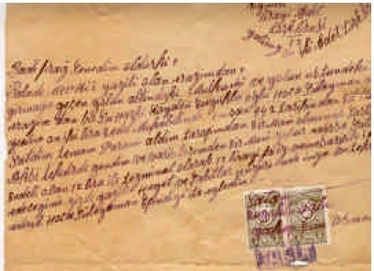

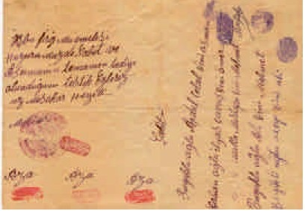
Fig. 4: An example of note of hand (Adi Senet)

belonged to places in the national boundaries of Turkey, 8277 volumes are belonged to places outside of the national boundaries. Nevertheless, these places were in the Ottoman national boundaries between 1847-1933. From 1934 to day, 320000 volumes second copy of Title Register also exist in the archive (GDLRC, 2005b).

GEOMETRICAL CADASTRE

Toe works of geometrical cadastre were commenced in 1908. This work done the aim of irrigation in villages Çumra- Karkın of Konya encloses area of 30000 hectares. On the other hand, in 1915, cadastral works were done in some districts such as Galata, Feriköy and Büyükada of Istanbul. However, the First World War interrupted the mentioned works (Türkkan, 1928). After the Turkish Republic was founded, the law with four articles which provide to establish the Cadastre Agency in the structure of Land Registry (Tapu Müdüriyet-i Umumiye) was came into force in 1925 (Aygün, 1935). Besides, the echıcation of technical staffs as map and cadastre expert and the forming of technical facilities were started with contributions of expert surveyors invited from Germany and France.

in Turkey, the fırst legal text, which supports the passing to geometrical cadastre, is the Turkish Civil Code accepted by translating exactly from German Civil Code. in this code, by defıning boundaries of immovable, horizontal boundaıy is demarcated with fixed comer points on the fıeld and mapped. in the course of time, in doing cadastre anticipated by the civil code, cadastre works were started in order to fonn modem Land Registers. Firstly, related organizations were founded. After that, Title Deed Registration and Cadastral Law (Kadastro ve Tapu Tahriri Kanunu) numbered 2613 was came into force in 1934. This law aimed at doing cadastre completely. However, in the case of urgent and compulsoıy, the doing of cadastre with writing by title registration (tapu tahriri) was continued with an article.
in the beginning, because enough technical staff and instruments did not exist, the works done slowly and in general, cadastre was done in cities and some places. Orienting of the cadastre to rural areas was implemented with Land Registration Laws (Tapulama Kanunları) numbered5602 (1950), 509 (1964) and 766 (1966). Thus, while the law numbered 2613 was being applied in only districts in boundaries of municipality, Land Registration Laws were applied in villages. lnitially, simple suıveying methods such as steel tape, compass, prism and tachometer were used. in the course of time, the using of measurements based triangulation points was commenced Cadastral maps based on triangulation points became compulsoıy in 1974. Cadastral maps based on the national geodetic network became compulsoıy with regulations inured in 1988. in taking the suıveying and map topics to the scope of works of Turkish Standards lnstitution, standards parallel with technical developments were formed
Geometrical cadastre is based on measurement, calculation and drawing on the technical side. At the end of this process, cadastral map called as "plan" is produced. Owners of properties in places whose cadastre is done are given the title certifıcation (Tapu in Turkish) which is a sample of registration (Fig. 5). Land parcel owners, if they want, are given a copy of parcel in graphical form. This copy is called as cadastral extract (Çap in Turkish). Sometimes, a document consisting both title and cadastral extract is given. This document is named as disposal certificate with cadastral extract (Çaplı Tassaruf Vesikası).
Suıveying methods in the various precisions changed accorcling to measurement instruments used in the doing of geometrical cadastre have been used. The simplest method is to use of a steel tape and compass. After that, prism-use method (prizmatik) whose precision is reasonable high was applied in the cities and more

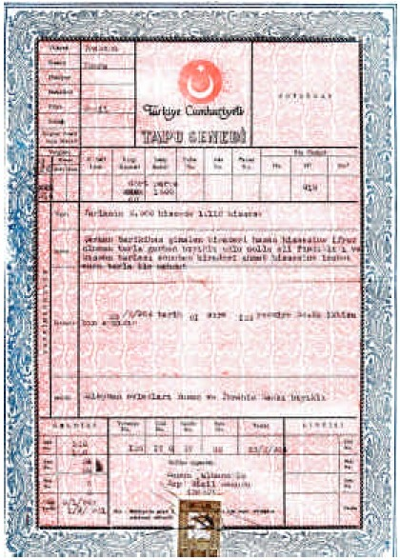

Fig. 5: An example of title certificate (Tapu in Turkish)

valuable land. After, classical tachometer, electronic tachometer and total station as final have been used in cadastral works. in addition, the photogrammetıy has been used in cadastral works in rural areas.
inTurkey, other than GDLRC, General Directorate of Forestıy has also done the cadastral works of forests. in this context, in doing the cadastre of forest areas, General Directorate of Forestıy has done to have places, which lose the characteristic of a forest in completely, removed outside of forest boundaries.
On the other hancı, the Organization of Cadastre and Land Registry has done renovation works on cadastral maps, which lose its own quality drastically, according to Renovation Law numbered 2859 dated 1983. However, these renovation works are not in the nature of second cadastre.
By using of cadastral products, activities of zoning applications and land readjustment have been done in urban areas and activities of land consolidation and land reform have been done in rural areas. in the final phase of these works, new cadastral maps are constituted by re-suıveying after application of new parcels formed.

in Turkey, scales of cadastral maps produced from measurements done accorcling to clifferent methods are 1/250 and 1/500 scaled in urban areas and are 1/1000, 1/2000 and 1/2500 scaled in rural areas. 1/5000 scaled is used for photogrammetric cadastral map.

NUMERICAL CADASTRE (CADAS1RAL INFORMATION SYSTEM)

in cadastral works, rather than drawing styles numerical values have been benefıted since the origin. For example, in the period of written cadastre, only coorclinate values were used to state size and positions of parcels. in the cadastre of geometrical, every kind measurement value was expressed with numbers.
The coorclinates of point, which is the fırst spatial data and benchmarking, which is required for application, were commenced to produce together with using of triangulation and polygon in cadastre. in parallel with development of computer technology, the production of automatic map sheet was started by calculating horizontal and vertical position of ali detail points. Thus, the automation at the works of calculating and plotting after cadastral measurements put on the agenda. After parcel based information was produced, this information is used for various works such as the taking linear outputs in easily, the producing of application values, the doing of area calculates, cross section in the certain clirection and the producing of perspective outlooks.
The fırst transiti on to numerical cadastre was started with cligitization of cadastral maps produced in Söke (a township in Turkey) in 1974. With development of
a speci:fic software, automatic plotters and electronic measurements instruments, automation system was started to bene:fit at the technical climension of cadastre. The GDLRC, firstly, improved pilot study in the capital city (Ankara). in the course of time, this application will be spread to other places of Turkey. There are two important projects started for this aim. üne is the Reform Project of Map and Cadastre (HAKAR in Turkish) which was commenced in 1986. Because of budget issues, the project could not be applied sufficiently at that time. The other one is Land Registry and Cadastre lnformation System Project (TAKBIS) (Fig. 6), which was commenced in Ankara/Cankaya Region in 1990. Besides, this project has been partly applied in some cities such as Ankara, Eski!lehir, Çankırı, Bolu, Kastamonu and Zonguldak (GDLRC, 2005a).
The transition to numerical cadastre provided the following possibilities. These are:

Errors derived from map drawing are brought away. Disagreements foımed by map sheets produced clifferent scales and clifferent coorclinate systems are ended.
The updating and monitoring of alterations became easier and cheaper.
More and more usable cligital information is produced for land and urban area planning management.
Making of statistical maps became easier.

in Turkey, it was encountered the important problems when numerical cadastre works were started. Particularly,

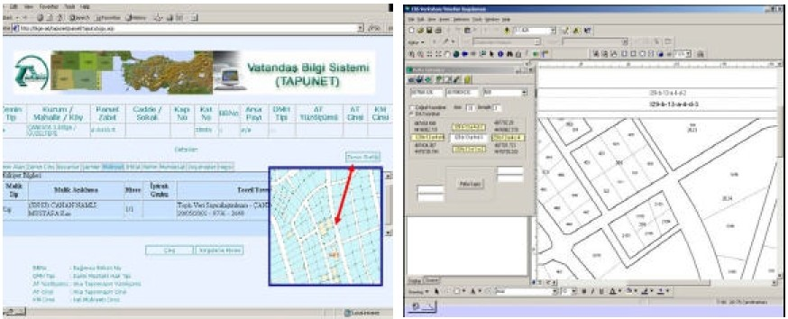

Fig. 6: A view of land registıy and cadastre infoımation system

if the digitization of parcel spatial information produced from measurements done with classical methods and not based on triangulation is done on map sheets, disagreements witlı land are appeared (Yomralıoğlu, 2000). In these cases, doing of second cadastre is suggested instead of producing non-up-to-date and low qualified cadastral irıformation (Bıyık, 1999). However, tlıe cadastre law in force does not permit to do second cadastre.
The involvement of private sector in cadastral works was commenced in 1987 with tender of the works of triangulation in seven districts (Çorbalı, 1987). However, because legal and adrninistrative preparations required for delivering of all of the cadastral works to private sector are not done, this attempt is restricted by some technical works (Tüdeş, 1988). But, alrnost all of tlıe cadastral works which are ongoing in today were transferred to private sector with a contract.
On the other hand, the cadastre with the priority is done in places exposed to catastrophe in Turkey. For example, the defining probable amendrnents in location of parcel at the end of the big earthquake occurred in Marmara Region in 1999 and the forming of new land register was compulsory. With this aim, the project named Land Information System for restructuring and developing of Marmara Eartlıquake Region (Merlis) was started witlı assistance from the World Bank. This study covers three provınces (Sakarya, Kocaeli and Yalova), 863 villages/districts, one million parcels and 11500 map sheets. The Merlis project was awarded a contract to private sector in 2004. In the context of this project, the geodetic network consisting of 387 points was completed to use for cadastre and development-construction of public facilities (narnely zoning). By watchirıg of tlıis network continuously, movements of crust of the earth can also be followed in scientific (GDLRC, 2005a).

CONCLUSIONS

Turkish cadastre as the inheritor of the Ottomans was started in l 300s with cadastre stated with a booking system. Until 1847, cadastre of lands particularly state lands was continued in the form of multipurpose information system. The main airn of land information produced in this process was economic. However, in today, these docurnents have legal and cultural values as proving docurnent. The title registers produced at the end of works done from 1847 to the Republic Period are accepted as the clairn docurnent having legal validity. At the same time, these docurnents are in the nature of title until the cadastre is done. In addition, after the Republic
was established, writing of these is continued. As a result of this study, we can say that the Ottoman land management system was a good working system and detailed information was registered about land parcels. This system has been sample for Turkish cadastral system and it will be useful that other countries (particularly developing countries) also benefit from this system.
On tlıe otlıer hand, from 1934 to day, tlıe doirıg of geometrical cadastre based on map has been continued. In present day, the cadastral works were completed by 99% in the cities and by 88% in rural areas (GDLRC, 2005a). However, tlıe sufficiency of standardization of works finished cannot be spoken. Therefore, in recent years, the projects in the nature of reform were started. In the process of transition to the European Union (the EU), the airn of Turkish cadastre is to constitute the structure which can harmonize with the cadastres of the EU member countries (Yavuz, 2004). In this context, the goal which multipurpose, wide-scoped and modem cadastre information system is established is approached step by step. Upon Turkey is member of the EU, it is not anticipated that any disagreements because of cadastral system exist. The reason of this is that Turkish Civil Code is coherent with the civil codes of Central European Countries.

REFERENCES

Anonymous, 1999. Docurnents on Ottoman Forestry-1, The Republic of Turkey, Mirıistry of Forestry, Pub. No. 094, Ankara, Turkey.
Aygün, A, 1935. Kadastro ve Tarihçesi (Cadastre and its history), Haritacılar Mecmuası, Yıl 2, Sayı 8, Harita Matbaası, Ankara (in Turkish).
Bıyık, C., 1987. Kadastro ve Eski Yazı Tapu Kayıtlan (Cadastre and Old-Writing Title Records), Prof Burhan Tansuğ Fotogrametri ve Jeodezi Sempozyumu, 8-9 Ekim 1987. TMMOB Harita ve Kadastro Mühendisleri Odası, İstanbul. Bildiriler kitabı, s. 115-125 (in Turkish).
Bıyık, C. and A Yavuz, 2003. The lmportance of Property Ownership and Management System in the Ottoman Empire in Point of Today, 2nd FIG Regioml Conference, Morocco, December 2-5, 2003.
Bıyık, C. and T. Yomralioğlu, 1994. Land lnformation Systems In 1500's, FIG XX Intemational Congress, Melboume Australia.
Bruce, W.M.G., 1983. Sirem Sancağı Mufassal Tahrir Defteri (Revenue Survey for District of Sirem), Pli. D. Türk Tarih Kurumu Basımevi, Ankara (in Turkish).

Çorbali, H, 1987. Tapu ve Kadastro Çalıpmalanndaki Son Dunnu ve Eğitim Çalıpmalan (Fiml Situation and Training Actions in the Cadastre and Land Registration Workings), 1. Harita Bilimsel ve Teknik Kuıultayı, 23-27 Şubat, Ankaıa. Bildiriler Kitabı, s. 19-24 Harita ve Kadastro Mühendisleri Odası yayım (in Tuıkish).
Çorbali, H and Özmen, İ., 1988. 3402 Sayılı Kadastro Kanunu Perlıi (The Explamtion of tlıe Cadastre Law Numbered 3402), Feıyal Matbaası Ankaıa (in Tuıkish).
FIG, 1995. FIG Statement on tlıe Cadastre, FIG Pub No. il,
http:www.fig.net/figtree. December 26, 2001.
GDLRC, 2005a. The General Directorate of Land Registıy and Cadastre Booklets, Ankaıa.
GDLRC, 2005b. The General Directorate of Land Registıy and Cadastre web page, wvVW.tkgm.gov.tr
Larsson, G., 1991. Land Registration and Cadastral Systems: Tools for Land Information and Management, Longman Scientific and Technical.
Nasulı, M., 1533. Beyan-ı Memzil-i Sefer-i Irakeyn-i Sultan Suleyınan Han, Yayım Haznlayan: Prof Dr. HG. Yuıduaydirı, Türk Taıih Kunnuu Yayınlan, 1976 Ankaıa (in Tuıkish).
Öksüz, H., 1988. Eski Mısır'da Toprak Mülkiyeti ve Kadastro Hizmeti (Land Ownership and Cadastre Service in old Egypt), Harita-Kadastro Mühendisliği Dergisi, Sayı 61, Sayfa 35, Ankaıa (in Tuıkish).
Sencer, M., 1969. Osmanlı Toplum Yapısı (The Structure of tlıe Ottoman Commuinty), Ant Yayınlan, No. 24, İstanbul (in Tuıkish).
Seylaın, G., 1983. Arşiv Hizmetleri (The Arclıive Services), Tapu ve Kadastro Genel Müdürlüğü Dergisi, Özel Sayı, 29 Ekim 1983, Ankara (in Tuıkish).
Tuncer, H, 1964. Osmanlı İmpaıatorluğunda Eyalet Taksimatı, Toprak Dağıtımı Ve Bunların Mali Güçleri (Provincial Divisions, Land Distribution and its Financial Powers inthe Ottoman Empire), (Ayni Ali Efendi'inn 1602 Taıihli Çalıpması, Türkçeye Çeviren: Hadiye Tuncer) Gürsoy Basımevi, Ankaıa, 1964 (in Tuıkish).
Tüdeş, T., 1988. Türkiye'de Kadastro Çalıpmalanm Özel Sektöıiüı Etkisi Ne Olabilir? (What is tlıe Effect of Private Sector to cadastral Works in Turkey?), Harita­ Kadastro 88 Sempozyumu, S.Ü Mühendislik­ Mimaıltk Fakültesi, 13 Mayıs, Konya (in Tuıkish).
Tüdeş, T. and C. Bıyık, 1997. Kadastro Bilgisi (lntroduction to tlıe Cadastre), KTÜ Yayınlan, Yayın No. 174, Trabzon (in Tuıkish).
Türkkan, H.Z., 1928. İlim Noktai Nazarından Kadastro Ne idi, Nedir, Ne Olacaktır?, Cumhuriyet Matbaası, İstanbul (in Tuıkish).
UN-HABITAT, 2005. lslaınic Land Theories and Their Applicatiorı, lslaın, Land and Property Reseaıch Series, vVWw.nıtlıabitat.org/programmes/ landtenure/ documents/ILP%201.doc.
Yavuz, A., 2004. Avrupa Birliği Ülkelerinde Kadastral Sistem Analizi ve Türkiye Kadastral Sisteminin Uyum Kapsamında Değerlendirilmesi (The Analysis of Cadastral System in the European Union Countries and the Evaluation of Turkey Cadastral System in the Adaptation Process), Ph.D Thesis, KTÜ Fen Bilimleri Enstitüsü, Trabzon (in Tuıkish).
Yomralioğk, T., 2000. Coğrafi Bilgi Sistemleri, Temel Kavramlar ve Uygulamalar (Geographic Information Systems, Basic Concepts and Applications), Seçil Ofset, İstanbul (in Tuıkish).

